H2020 Marie Skłodowska-Curie Action
Innovative Training Network
COMPLETE
Cloud-MicroPhysics-Turbulence-Telemetry
1° Main Network-Wide Training Event
Torino, 19-22/06/2017
Politecnico di Torino, Sala Audiovisivi 1 (SELM)
Programme Day 1 - Monday
9.15-10.00 | Welcome of the Politecnico di Torino.  COMPLETE Project Introduction | D.Tordella, 30 min
10.00-11.00 | Presentation of the ESR students :  - ESR1 : Taraprasad Bhowmick (Politecnico di Torino)  - ESR2 : Tessa Chiara Basso (Politecnico di Torino)  - ESR3 : Tai Wada (Imperial College London)  - ESR4 : Vishnu Satheesh Kumar Nair (Imperial College London)  - ESR5 : Guus Bertens (Max Planck Institut für Dynamik und Selbstorganisation)  - ESR6 : Johannes Guettler (Max Planck Institut für Dynamik und Selbstorganisation) | 10 min each
11.00-11.30 | Coffee Break | 30 min
11.30-12.40 | Presentation of the ESR students :  - ESR7 : Marco Boetti (Tel Aviv University)  - ESR8 : (Max Planck Institut für Dynamik und Selbstorganisation)  - ESR9 : Moein Mohammadi (Uniwersytet Warszawski)  - ESR10 : Emmanuel Akinlabi (Uniwersytet Warszawski)  - ESR11 : Sara Shamekh (Laboratoire de Meteorologie Dynamique)  - ESR12 : (Envisens Srl)  - ESR13 : Mina Golshan Koviji (Politecnico di Torino)  - ESR14 : Joyraj Chakraborty (Sitael Spa) | 10 min each
12.40-14.00 | Lunch – (Ristorante Quattro Soldi, Corso Castelfidardo, 7) | 80 min
14.00-15.30 | Beneficiaries present their research activities :  Politecnico di Torino  Imperial College London  Max Planck Institut für Dynamik und Selbstorganisation  Tel Aviv University  Uniwersytet Warszawski  Laboratoire de Meteorologie Dynamique  Envisens Srl  Sitael Spa | 10 min each  All Partners
15.30-16.00 | Coffee Break | 30 min
16.00-18.30 | Supervisory Board Meeting :  All items of the Agenda to be circulated shortly. | 2h 30 min  SB members: Coordinator, beneficiaries’ representatives, MC PhD supervisors, external advisors
16.00-18.30 | Parallel moment of ESR socialization with final election of the two representatives inside the Supervisory Board and of the four annual ESRs representatives inside the Science & Training Committee [Room 3N] | 2h 30 min  ESRs

Programme Day 2 - Tuesday

9.30-9.35 | Short presentation of Prof. Hanna Pawlowska from the University of Warsaw | S.Malinowski, 5 min
9.35-10.30 | Introduction to clouds :  - definition of clouds  - thermodynamic processes leading to cloud formation  - observations and measurements of clouds  - cloud classification  - clouds and weather  - clouds and climate | S.Malinowski, 1 h
10.30-11.00 | Coffee Break | 30 min
11.00-12.30 | Lecture of CLOUD MICROPHYSICS :  - Why do we study cloud microphysics?  - What is cloud microphysics?  - How to describe cloud microphysical properties?  - Microphysics processes :  - heterogeneous nucleation, activation  - condensational growth  - rain formation  Open issues :  - in-cloud activation  - spectrum broadening by entrainment/mixing processes  - impact of small-scale turbulence on collision/coalescence  Observation, measurements | H.Pawlowska, 90 min
12.40-14.00 | Lunch – (Ristorante Quattro Soldi, Corso Castelfidardo, 7) | 80 min

14.00-16.00 | Clouds and turbulence :  - turbulence – an introduction  - scales of flow in the atmosphere  - turbulence kinetic energy  - atmospheric boundary layer, shear layers, moist convection in the atmosphere  - turbulence kinetic energy in clouds: sources and sinks  - effects of turbulence on clouds (entrainment, mixing, cloud evolution, cloud persistence, small-scale interactions between turbulence, thermodynamics and microphysics) | S.Malinowski, 2 h
16.00-16.30 | Coffee Break | 30 min
16.30-17.30 | Q&A session  Questions, answers and open issues | S.Malinowski  H.Pawlowska,1h
17.30-18.30 | Science & Training Committee Meeting for preliminary analyses on future developments | 1h  STC
20.15 | Dinner (“Circolo dei Lettori”, via Bogino 9)

Programme Day 3 - Wednesday

9.00-9.05 | Short presentation of Prof. Marco Cantamessa and Francesca Montagna from Politecnico di Torino | F. Montagna, 5 min
9.05-10.30 | Understanding the phenomena that occur behind a technology-based project:  - From invention to innovation  - Where are we in the innovation pipeline? | F. Montagna, 90 min
10.30-11.00 | Coffee Break | 30 min
11.00-12.30 | Understanding the phenomena that occur behind a technology-based project:  - S-curves  - Understanding paradigms  - Framing the innovation | F. Montagna, 90 min
12.40-14.00 | Lunch – (Ristorante Quattro Soldi, Corso Castelfidardo, 7) | 80 min

14.00-16.00 | Understanding the phenomena that occur behind a technology-based project:  - Disruptive and sustaining innovations  - Dynamics of innovation | F. Montagna, 120 min
16.00-16.30 | Coffee Break | 30 min
16.30-18.40 | Learning how to move from an idea to entrepreneurship:  - The role of technology-based entrepreneurship  - What is an entrepreneur?  - Can I be an entrepreneur?  - What types of technology ventures can we think of? | M. Cantamessa, 120 min

Programme Day 4 - Thursday

9.00-10.30 | How to make the business model grow  - Defining the concept of business model  - The business model canvas | M. Cantamessa, 90 min
10.30-11.00 | Coffee Break | 30 min
11.00-12.30 | How to make the business model grow  - Competitive advantage and core competencies and capabilities  - Elements to make up a strategy  - Roadmapping | M. Cantamessa, 90 min

How to reach the Politecnico di Torino
(main entrance: Corso Duca degli Abruzzi 24)

Sala Audiovisivi 1 (SELM) is located next to the entrance in via Boggio (see map).

Flight connections
The "Sandro Pertini" international airport (Torino Caselle) is connected with all major european hubs, including Rome, Paris, Frankfurt, Munich, London, Brussels, Madrid, Barcelona. It has links with the city centre via an Airport Shuttle whose terminus is next to the principal railway stations of Porta Nuova (corso Vittorio Emanuele) and Porta Susa. It takes about 40-45 minutes to reach the city centre with the shuttle. We suggest you to get out at Porta Susa station to reach the Politecnico. From this point you can take a city bus/tramway or walk as described below.
For more information about the airoport of Torino Caselle: http://www.aeroportoditorino.it/ .
It is possible to reach Torino also via the airports of Milano Malpensa and Milano Linate. From Milano you can take the train to Torino (1h 45min, a train leaves every hour), or the Sadem bus shuttle.

Both bus shuttles (from Torino Caselle and from Milano Malpensa Airports) will leave you in Corso Bolzano 42, in front of Porta Susa railway station. The shuttle from Torino caselle stops also in front of Porta Nuova railway station.
Prices and timetables of the shuttles to Torino can be found in the Sadem corporation website:
http://www.sadem.it/en/prodotti/collegamento-aeroporti.aspx

Railways Connections
Trains arrive at the stations of Torino Porta Nuova (main station) and Torino Porta Susa, both situated in the city centre. Both are not far from the Politecnico di Torino. Taxis are available in front of both stations.
From Porta Nuova:
On foot: exit the station on the main lateral exit on the left (via Sacchi), follow via Sacchi till you reach Corso Stati Uniti (100 m), then follow Corso Stati Uniti till the end. It ends in Corso Casterfidardo. Turn left and walk about 400 m. Two buldings over the street mark the Politecnico. The entrance is a gate on your right, “Sala Audiovisivi 1 /SELM” room is near via Boggio, so you have to cross western part the Politecnico (see map 2).
By bus: exit from the main entrance (corso Vittorio Emanuele), and cross the street. You will find a bus stop. You can take bus number 33. Get out after 5 stops, you'll be in front of the main entrance of the Politecnico in Corso Duca degli Abruzzi 24 (a white building with the text “Politecnico” on top of the gate). Enter the Politecnico and cross it to Room “Sala Audiovisivi 1/SELM” (opposite side!). It can be more convenient to get out after 3 additional stops, so that you will be in Corso Peschiera at the corner with Corso Ferrucci (bottom left corner of the Politecnico in map 2). Follow Corso Ferrucci for 200 meters and enter the Politecnico.
From Porta Susa:
On foot: exiting the station toward Corso Inghilterra, follow Corso Inghilterra (the station will remain on your left) for about 1000 m. The road changes name (it becomes Corso Casterfidardo). Two buidings over the street mark the Politecnico. The entrance to room 3I is on your right, just before the first building. (it takes no more than 20 minutes to reach Corso Castelfidardo 32 on foot). If you exit through the main entrance of the station, you’ll be in Piazza XVIII Dicembre/corso Bolzano. In that case Follow Corso Bolzano (the station will remain on your right) for few hundreds meters till Corso Vittorio Emanuele, then you’ll find Corso Castelfidardo about 30 m on your right (see map 1).
By bus: exiting the station, you'll find a bus stop in front of you. Take tramway number 10, direction south (Mirafiori). It will carry you to the main entrance of the Politecnico after 4 stops.

Information about the trains to Torino can be found in the webpage of the Italian state railway company http://trenitalia.it/ or from http://reiseauskunft.bahn.de/

Bus/tramway information (including a path planning function):
http://www.gtt.to.it/cms/en/
Bus tickets can be bought in any newsstand or tobacconist shop (also present in both stations).

Map 1 – How to reach the Politecnico di Torino

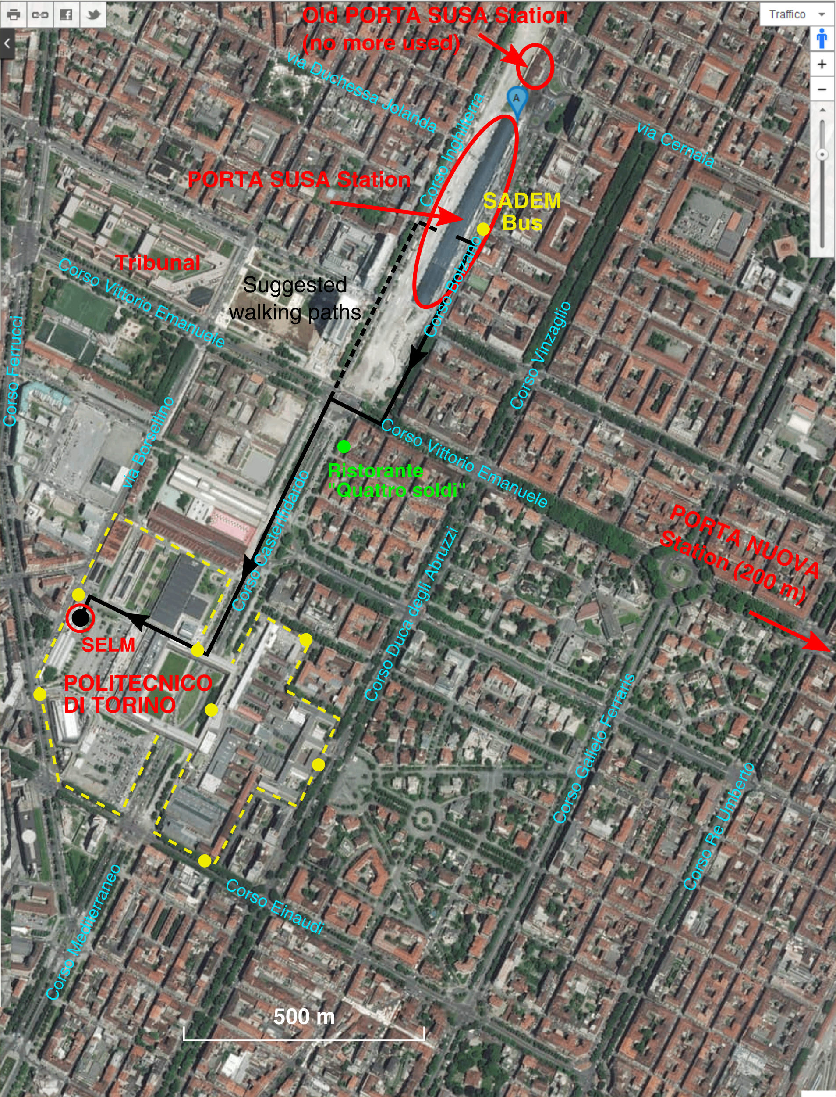

Map 2 – Position of “Sala Audiovisivi 1 (SELM)” within the Politecnico di Torino

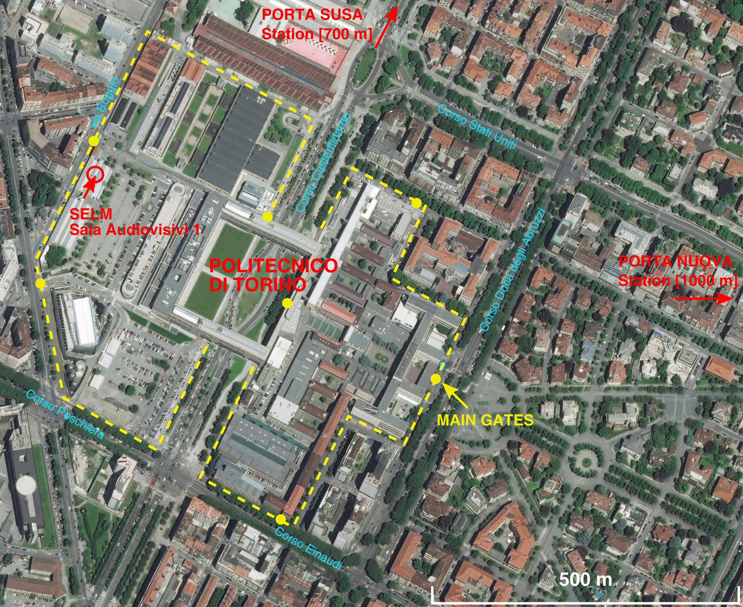

Few Hotels and B&B not far from the Politecnico

Art Hotel Boston
Via Massena 70
Tel: +39 011 500 359
10 minute walk from Porta Nuova Station, it is in the bottom-right corner of Map 1

Hotel Dock Milano
Via Cernaia 46
Tel: +39 011 5622622
50 m from Porta Susa Station

BW Plus Hotel Genova
Via Sacchi 14/B
Tel: +39 011 5629400
50 m from Porta Nuova Station

Gianduja B&B
Corso Duca degli Abruzzi 48
Tel: +39 345 417 6248
200 m from the Politecnico (two cm below the bottom edge of map 2)

Best Quality Hotel Gran Mogol
Via Guarini 2
Tel: +39 011 5612120
100 m from Porta Nuova Station

